SMALLEST NUMBER IN AN ARRAY

EXP NO: 10

AIM: To find the smallest number from an array using 8085 processor.

ALGORITHM:

1) Load the address of the first element of the array in HL pair.

2) Move the count to B register.

3) Increment the pointer.

4) Get the first data in A register.

5) Decrement the count.

6) Increment the pointer.

7) Compare the content of memory addressed by HL pair with that of A register.

8) If carry=1, go to step 10 or if carry=0 go to step 9

9) Move the content of memory addressed by HL to A register.

10) Decrement the count.

PROGRAM:

LXI H,2050

MOV C,M

DCR C

INX H

MOV A,M

LOOP1: INX H

CMP M

JC LOOP

MOV A,M

LOOP: DCR C

JNZ LOOP1

STA 2058

HLT

INPUT & OUTPUT

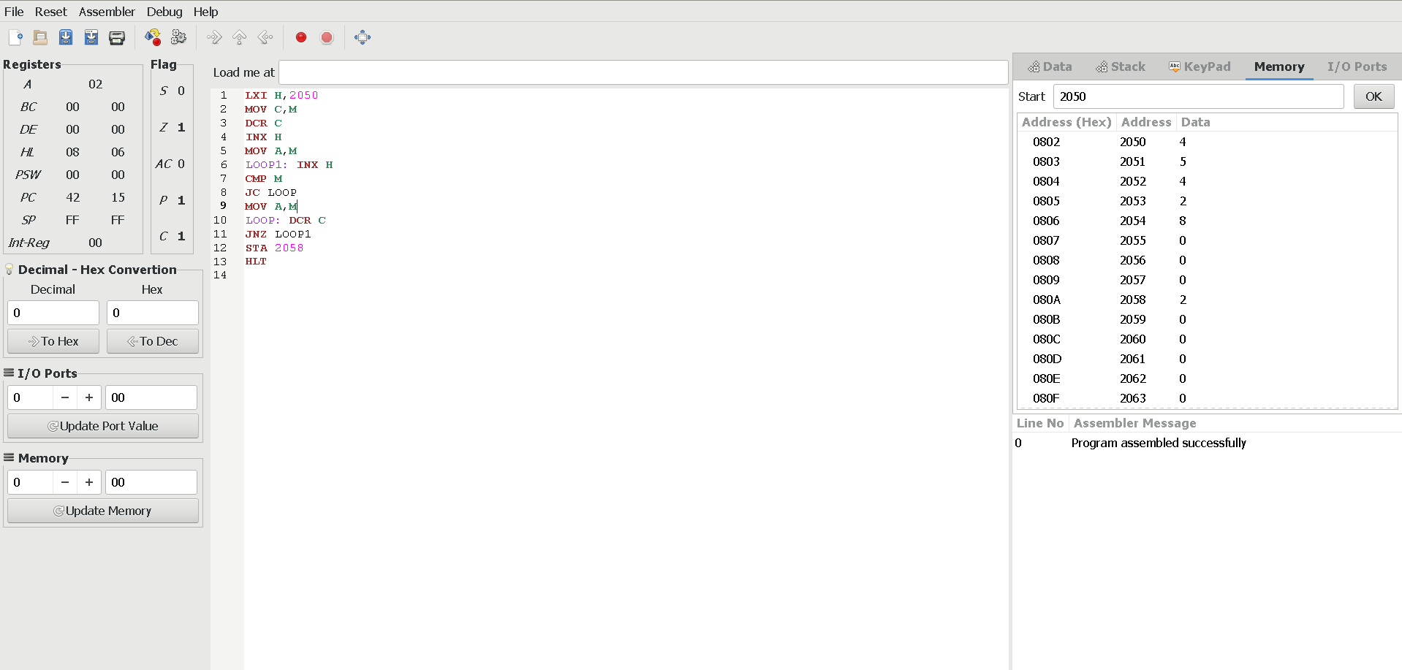

RESULT: Thus the program was executed successfully using 8085 processor simulator.